


AB Bank Zambia

Monthly Report
September 2025

Contents
1. Executive Summary 2
1.1. Key Highlights: 2
1.1.1. Incident Volume & Trends: 2
1.1.2. Detection & Response Performance: 2
1.2. Incident Trends & Analysis: 3
1.3. High-Severity Incidents: 4
2. September Alerts & Incidents Overview 4
2.1. Overall Volume 4
2.2. Incidents Processing 5
2.3. Mean Time To Detect (MTTD) 5
3. Incidents Highlights 6
3.1. Top Incidents by type 6
3.2. Analysis of Key Incident Trends 7
1. Source Stopped Sending Data: Security Events (357 Incidents) 7
2. FortiGate UTM Alerts (224 Incidents) 7
3. Admin Account Logon Failure (221 Incidents) 7
4. Authentication Attempt – Default Account (219 Incidents) 7
5. FortiGate Successful Login (213 Incidents) 7
6. rm_rasford.lembalemb FortiClient VPN Connected (53 Incidents) 8
7. FortiGate Logon Failure (52 Incidents) 8
8. rm_rasford.lembalemb FortiClient VPN connected outside of Business Hours (51 Incidents) 8
9. Incidents Summary Alert (49 Incidents) 8
10. Brute Force Attempts to Windows Servers (39 Incidents) 8
3.3. High Severity 9
3.3.1. High Severity Incidents Analysis 9
1. Preview: Possible multistage attack activities detected by Fusion (8 Incidents) 9
2. Non Domain Controller Active Directory Replication (2 Incidents) 10
4. Cybersecurity Trends and Threats 10
4.1. Key Threats and Incidents 10
4.2. Regional Spillover and Infrastructure Risks 10
4.3. Government and Industry Response 11
5. Conclusion and Recommendations 11
5.1. Recommendations 11
5.2. Conclusion 11
Appendix – Test-server Alerts 12
Total Incidents by Severity 13
Top 10 Incidents 13
High Severity Incidents 13

Executive Summary
This security report provides an in-depth analysis of security incidents, alerts, and operational activities managed by TeKnowledge for AB Bank Zambia during the reporting period (September 2025). The findings highlight key security trends, detection and response performance, and proactive measures taken to enhance the organization’s security posture.

Key Highlights:

Incident Volume & Trends:
A total of 1887 security incidents were generated in the production environment and 112 Security incidents in the Test Environment. All incidents were processed in Microsoft Sentinel, encompassing both manually investigated cases and automated detections.
The most prevalent security events still include Source Stopped Sending Data: Security Events, Authentication Attempt - Default Account, Admin Account Logon Failure, FortiGate UTM Alerts and
FortiGate Successful Login highlighting the efficacy of the Security on Log-Collection Status from Critical Server(s), Access Notifications on Digital assets and Prompts about Suspicious Threat attempts against the environment.

Detection & Response Performance:
Mean Time to Detect (MTTD): 3 minutes and 32 seconds, ensuring timely identification of potential threats.
Additionally, the breakdown of MTTD by severity is as follows:
High Severity: 2 minutes 48 seconds
Medium Severity: 3 minutes and 32 seconds
Informational: 3 minutes and 41 seconds
Mean Time to Resolution (MTTR): The average Mean Time to Resolution (MTTR) for this reporting period was on an average of 40 minutes. The screenshot below provides a detailed breakdown by severity.

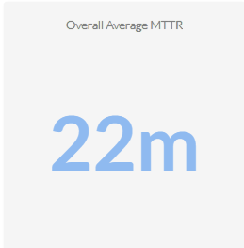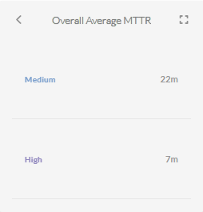

Average time to First Response: The average Time to First Response was 13 minutes. Where High Severity Incidents were responded to within 4 minute. See the screenshot below for the breakdown according to the incidents’ severity.
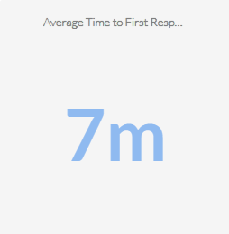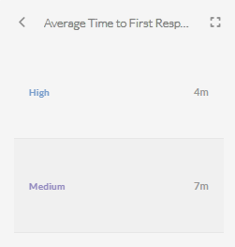

Incident Trends & Analysis:
The top recurring incident types identified in September accounted for 1052 of the total incidents. These incidents were mainly tied to Source Stopped Sending Data: Security Events, Authentication Attempt - Default Account, Admin Account Logon Failure, FortiGate UTM Alerts and
FortiGate Successful Login indicating High Service-Account Access failures, external unified Threat Management Notifications and Access to critical Assets Notification.
The most frequent alerts were related to:
- Source Stopped Sending Data: Security Events – 253
- Authentication Attempt - Default Account – 213
- Admin Account Logon Failure – 210
- FortiGate UTM Alerts – 199
- FortiGate Successful Login – 177
All these incidents were thoroughly reviewed and escalated where necessary, helping to maintain Operational stability and security to the critical Assets.

High-Severity Incidents:
A total of 10 alerts were categorized as high severity, which entails Possible multistage attack activities detected by Fusion and Non Domain Controller Active Directory Replication. The high-severity case confirmed to be carried out by an Authorized IT Administrator.

September Alerts & Incidents Overview

Overall Volume
In the month of September, a total of 1887 incidents from production environment were handled on MS Sentinel. Further breakdown in severity showed that 10 incidents were High Severity, 1828 were of Medium Severity, and 49 Informational Incidents. This volume includes manually-processed incidents and automatically-addressed incidents, through pre-configured automation protocols.
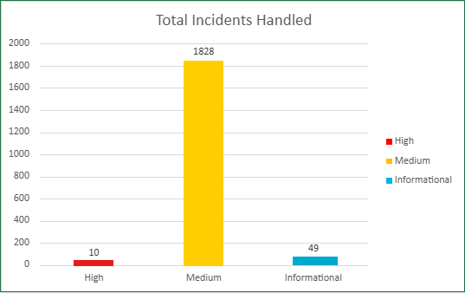

Incidents Processing
During the reporting period, TeKnowledge successfully monitored, detected, and responded to a total of 1887 security incidents within the AB Bank Zambia production environment. The SOC team processed all incidents, ensuring a comprehensive approach to threat detection and response.

Mean Time To Detect (MTTD)
The average Mean Time to Detect (MTTD) for this reporting period was 3 minutes and 32 seconds. Average Detection time for High Severity was 2 minutes 48 seconds, Average detection time for Medium severity was 3 minutes 32 seconds and Informational incidents were averagely detected at 3minutes 41 seconds
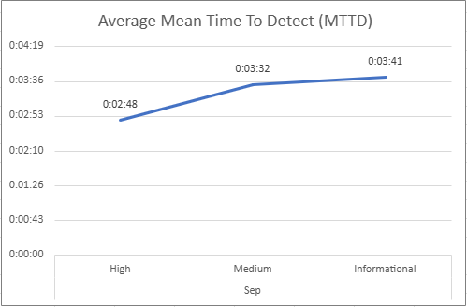

Incidents Highlights

Top Incidents by type
During the reporting period, TeKnowledge monitored security incidents, identifying the most prevalent issues within your environment. Below is a breakdown of the top incident types detected:
Incident Title | Count of Title
Source Stopped Sending Data: Security Events | 357
FortiGate UTM Alerts | 224
Admin Account Logon Failure | 221
Authentication Attempt - Default Account | 219
FortiGate Successful Login | 213
rm_rasford.lembalemb FortiClient VPN Connected | 53
FortiGate Logon Failure | 52
rm_rasford.lembalemb FortiClient VPN connected outside of Business Hours | 51
Incidents Summary Alert | 49
Brute Force Attempts to Windows Servers | 39
Grand Total | 1478

Analysis of Key Incident Trends
During this reporting period, TeKnowledge identified and categorized multiple security incidents within the AB Bank Zambia production environment. The breakdown below highlights key trends, notable threat patterns, and actionable recommendations to improve detection and response capabilities
- Source Stopped Sending Data: Security Events (357 Incidents)
Description: This rule triggers an alert if limited or no data is received from the SecurityEvent table, indicating that the source has stopped sending the required logs.
Observation: These events were confirmed to be caused by log-forwarding agents on the Monitored Servers, the service did not start automatically after server maintenance. Maintenance was carried out on Production servers and not all the log-forwarding agents on all the servers started automatically.
- FortiGate UTM Alerts (224 Incidents)
Description: This rule detects FortiGate Unified Threat Management (UTM) alerts by parsing Syslog messages that contain UTM alert indicators and identifying relevant details like source and destination IPs.
Observation: All the Malicious requests to the critical Servers were dropped by the firewall.
- Admin Account Logon Failure (221 Incidents)
Description: This rule detects failed logon attempts for admin accounts. It monitors Event ID 4625 and filters based on failure reasons that indicate issues such as unknown user, bad password, or logon time restriction violations. The rule targets specific admin and service accounts from watchlists.
Observation: These incidents were generated mostly due to wrong login credentials entered from Administrators accounts on the Critical Servers.
- Authentication Attempt – Default Account (219 Incidents)
Description: This rule monitors authentication attempts using default accounts like "Administrator," "Root," or "Guest."
Feedback: Most of the failed authentication attempt was from a ‘Guest’ account on a critical Server(s). Though all attempt failed signifying a proper security measure for such vulnerability. Further review confirmed that the failure was due to restriction and policy against “Guest” account login on Critical Servers
- FortiGate Successful Login (213 Incidents)
Description: This rule detects successful logins to FortiGate's management console by parsing the Syslog messages and extracting login details like user, source IP, and destination IP.
Observations: All detected logins were verified to be authorized VPN connections initiated by approved users. No unauthorized access was observed.
- rm_rasford.lembalemb FortiClient VPN Connected (53 Incidents)
Description: This rule detects successful FortiClient VPN connections by parsing Syslog messages from FortiGate devices and extracting relevant user and IP information
Feedback: The VPN connections originated from an authorized administrator account and were validated as legitimate.
- FortiGate Logon Failure (52 Incidents)
Description: This rule detects failed login attempts on FortiGate devices' administrative interface. It parses the Syslog messages for failure events, while excluding specific benign scenarios.
Observations: The failed logins were attributed to either expired credentials or mistyped passwords, all associated with legitimate users within the environment. No indication of malicious activity was found.
- rm_rasford.lembalemb FortiClient VPN connected outside of Business Hours (51 Incidents)
Description: This rule detects FortiClient VPN connections made outside of standard business hours (5 AM to 3 PM, Monday to Friday).
Recommendation: These incidents overlap with those detected by the FortiClient VPN Connection rule (see Item 6). It is recommended to consolidate both rules. When a VPN connection occurs outside business hours, the primary rule (Item 6) should dynamically tag the event as “Outside Business Hours”.
This optimization will ensure a single alert is generated instead of duplicate alerts for the same event.
- Incidents Summary Alert (49 Incidents)
Description: This rule produces a summary count of incidents generated in the past 12hrs.
- Brute Force Attempts to Windows Servers (39 Incidents)
Description: These incidents triggers when there are more than 5 failed login attempts to the domain controller within a 10-minute window
Observation: These were confirmed to be caused by change in Login credentials of active sessions belonging to legitimate users. The Servers affected couldn’t update Group policy due to misconfigured DNS.

High Severity
During the reporting period, Ten high-severity incidents were recorded. The incidents were confirmed to be carried out by authorized IT Administrators and Dedicated Service Accounts for Active Directory Service.
Incident Title | Sum of count_
Preview: Possible multistage attack activities detected by Fusion | 8
Non Domain Controller Active Directory Replication | 2
Grand Total | 10

High Severity Incidents Analysis
- Preview: Possible multistage attack activities detected by Fusion (8 Incidents)
Review: Microsoft Sentinel uses Fusion, a correlation engine based on scalable machine learning algorithms, to automatically detect multistage attacks by identifying combinations of anomalous behaviors and suspicious activities that are observed at various stages of the kill chain. On the basis of these discoveries, Azure Sentinel generates incidents that would otherwise be very difficult to catch. By design, these incidents are low-volume, high-fidelity, and high-severity, which is why this detection is turned ON by default.
On further investigation, it was discovered to be Successful and Failed Logon activities of Authorized IT Administrator in Critical Servers within the Production Environment
- Non Domain Controller Active Directory Replication (2 Incidents)
Review: This rule detects potential attempts by non-computer accounts (non domain controllers) to retrieve/synchronize an active directory object leveraging directory replication services (DRS). A Domain Controller (computer account) would usually be performing these actions in a domain environment.
On further investigation, it was discovered that this was an authorized activity of a dedicated Service Account for Azure AD Connect synchronization.

Cybersecurity Trends and Threats
In September 2025, Zambia continued to confront increasing urgency around cyber resilience, especially in financial services and regulatory policymaking. While no large-scale breach disclosures surfaced, the Bank of Zambia and legislative bodies issued warnings and proposals that underscore an elevated threat environment. The period also saw momentum in updating ICT laws and calls for stronger defense against fraud and cyber threats Cybersecurity Trends and Threats - Zambia (September 1-30, 2025)

Key Threats and Incidents
On September 18, 2025, the Governor of the Bank of Zambia (BOZ), Dr. Denny Kalyalya, publicly urged banks to adopt more aggressive cybersecurity and anti-fraud measures. He emphasized the rising nature of digital threats in banking and called for inter-bank cooperation and stronger defenses.
No confirmed public reports of ransomware, mass data breaches, or systemic attacks in September surfaced in reputable media or government sources for Zambia.

Regional Spillover and Infrastructure Risks
New bills introduced in mid-September to amend Zambia's Electronic Communications & Transactions law and strengthen cyber regulation signal awareness of growing regional threats. These amendments aim to resolve conflicts with the 2025 Cybersecurity Act and bolster public key infrastructure and digital trust.
The continued enforcement of the Cyber Security Act, 2025 and Cyber Crimes Act, 2025 places pressure on critical infrastructure and digital services to align with higher regulatory expectations and exposure to oversight.

Government and Industry Response
The Zambian Cabinet approved the submission of two bills to Parliament in September 2025: (1) an amendment to the Electronic Communications & Transactions Act to align with the new Cybersecurity Act, and (2) a Postal Services (Repeal) Bill to modernize regulation amid e-commerce and digital shifts. These laws attempt to harmonize older legislative frameworks with the demands of the digital era. Act 3, Act 4
• The Information and Communications Technology Association of Zambia (ICTAZ) released its 2025-2027 strategic plan, seeking to strengthen professional conduct, capacity, and leadership in Zambia's ICT sector.
• In response to perceived misinterpretations, government officials reaffirmed that lawful interception under the Cybersecurity Act must follow due process and that surveillance powers do not permit arbitrary monitoring.
Links to Sources: Lusaka Times, Ecofin Agency, The Agency Media, Developing Telecoms, National Assembly of Zambia

Conclusion and Recommendations

Recommendations
Optimize analytic rules to use consistent entity mapping (Account, Host, IP, Process, File hash, URL/Domain) to enable auto-grouping, speed triage, suppress non-prod noise, and improve metrics.
Expand SSH detection coverage by developing additional analytic rules to identify and monitor SSH-based connection activities
Consider integrating your WithSecure EDR solution with Microsoft Sentinel as this integration will provide centralized monitoring by consolidating endpoint and cloud workload security events into a unified dashboard, enabling more efficient incident response through streamlined investigation workflows and automation.

Conclusion
The September 2025 reporting period marked a significant step forward in the security operations of AB Bank Zambia, with TeKnowledge continuing to provide dedicated 24/7 monitoring, incident detection, and rapid response through the Microsoft Sentinel platform. A total of 1887 alerts were processed a significant increase from the previous month reflecting the need for optimization of the analytical rules in the environment.
The most detected threats included Source Stopped Sending Data: Security Events, Authentication Attempt - Default Account, Admin Account Logon Failure, FortiGate UTM Alerts and
FortiGate Successful Login, underscoring the need for sustained vigilance in identity/access management as well as operational status of critical assets.
TeKnowledge’s SOC demonstrated high operational efficiency, with the following key performance:
- Mean Time to Detect (MTTD): 3 minutes and 32 seconds
- Average Time to First Response: 13 minutes (High 4minute, Medium 13minutes)
- Average Mean Time to Resolution: 40 minutes

The high-severity incidents recorded during this period, involving Preview: Possible multistage attack activities detected by Fusion by legitimate and Authorized administrators and Non Domain Controller Active Directory Replication carried out by Authorized Service account for Azure Active Directory Sync Service .
As we move forward, TeKnowledge remains dedicated to strengthening your organization’s defences through:
- Continuous monitoring and rapid threat detection
- Strategic improvements to rule coverage and incident handling workflows

We appreciate the trust placed in TeKnowledge to safeguard AB Bank Zambia’s digital environment and look forward to our continued partnership in building a more secure and resilient infrastructure.

Appendix – Test-server Alerts
This section documents alerts generated on test servers (non-critical) during the reporting period. These events are excluded from SLA/MTTR metrics and captured for transparency and auditability.

Total Incidents by Severity
Severity | Count of Severity
High | 6
Medium | 106
Grand Total | 112

Top 10 Incidents
Title | Sum by Title
Admin Account Logon Failure | 33
Authentication Attempt - Default Account | 19
ABBANK\rm_lameck.kaluba Has Logged Into S-ABZ-myMBS-T03.abbank.co.zm | 13
ABBANK\rm_kangwa.mwaba Has Logged Into S-ABZ-myMBS-T03.abbank.co.zm | 8
ABBANK\andrey.botrasov Has Logged Into S-ABZ-WALLET-T1.abbank.co.zm | 6
ABBANK\rm_lameck.kaluba Has Logged Into S-ABZ-WALLET-T1.abbank.co.zm | 6
Brute Force Attempts to Windows Servers | 6
Preview: Possible multistage attack activities detected by Fusion | 6
User Removed from a Security Enabled Group | 3
User Added to Critical Group | 2
Grand Total | 102

High Severity Incidents
Title | Count of Title
Preview: Possible multistage attack activities detected by Fusion | 6
Grand Total | 6

